MSC Pre-Assessment for
UK Southwest lobster

Project UK Fisheries Improvements

December 2016
Prepared For: Project UK Fisheries Improvements.
Claire Pescod
Prepared By: Crick Carleton

Contents
Contents i
Glossary ii

1 Introduction 1
1.1 Aims/scope of pre-assessment 1
1.2 Background 1
1.3 Constraints to the pre-assessment of the fishery 2
1.4 Unit(s) of Assessment 2
1.5 Total Allowable Catch (TAC) and Catch Data 2
2 Description of the fishery 4
2.1 Scope of the fishery in relation to the MSC programme 4
2.2 Introduced Species / Inseparable Stocks (IPI) / Enhanced Fishery / Low Trophic 4
2.3 Overview of the fishery 4
2.4 Other elements in the fishery 6
3 Evaluation Procedure 8
3.1 Assessment methodologies used 8
3.2 Summary of consultations during pre-assessment 8
3.3 Applicability of the default assessment tree 8
3.4 Approach to Scoring 8
3.5 Stakeholders to be consulted during a full assessment 8
4 Traceability (issues relevant to Chain of Custody certification) 9
4.1 Eligibility of fishery products to enter further Chains of Custody 9
5 Preliminary evaluation of the fishery 10
5.1 Key findings from the pre-assessment 11
5.2 Expectations regarding use of the Risk-Based Framework (RBF) 11
Appendix 1 – Pre-assessment Scoring Sheets 12
Appendix 2 – References 27
Appendix 3 – Graphics 29

Glossary
CFP Common Fisheries Policy
CL Carapace Length
DCF Data Collection Framework
Defra Department of the Environment and Rural Affairs
EMS European Marine Sites
ETP Endangered, Threatened & Protected
EU European Union
EC European Commission
FAO Food and Agriculture Organisation of the United Nations
FCR Fisheries Certification Requirements
FIP Fishery Improvement Project
GPRS General Packet Radio Service (mobile telephony)
ICES International Council for the Exploration of the Sea
IFCA Inshore Fisheries & Conservation Authority
JRC European Commission Joint Research Centre
LTL Low Trophic Level
NFFO National Federation of Fishermen’s Organisations
MCZ Marine Conservation Zone
MLS Minimum Landing Size
MMO Marine Management Organisation
MSC Marine Stewardship Council
MSY Maximum Sustainable Yield
PI Performance Indicator
PO Producer Organisation
PRI Point at which recruitment is impaired
PUKFI Project UK Fisheries Improvements
RBF Risk Based Framework
SAC Special Area of Conservation
SAGB Shellfish Association of Great Britain
SG Scoring Guidepost
SPA Special Protected Area
STECF Scientific, Technical and Economic Committee for Fisheries
TAC Total Allowable catch
UoA Unit of Assessment
UoC Unit of Certification
VHS Very High Frequency
VME Vulnerable Marine Ecosystem
WGCRAB ICES Working Group on the Biology and Life History of Crabs

Introduction

Aims/scope of pre-assessment
This report presents an update of the Marine Stewardship Council (MSC) pre-assessment of the UK Southwest lobster (Homarus gammarus) fishery that was originally included as part of Project Inshore in 2013. As such, the primary aims of this update of the earlier pre-assessment are to:
- Undertake a further review of available fishery-specific data
- Identify the key changes that have occurred in either the operation or the management of the fishery which may lead to changes in expected MSC scoring outcomes
- Based upon updated information, review the performance of the fishery against the latest version of the MSC certification requirements, which includes a number of changes since the time of the original pre-assessment.
- Present revised pre-assessment scoring and supporting rationale.
As this pre-assessment is intended to be an update of an earlier pre-assessment, a simplified reporting template has been used. This seeks to include the normative requirements of the MSC pre-assessment process – in particular in relation to definition, scope and scoring of the fishery – but does not include the level of wider background and description which would sometimes be included in a pre-assessment report.
However, this simplified pre-assessment update process still involves providing a provisional evaluation against MSC Performance Indicators (PIs) and Scoring Guideposts (SGs), to inform how the fishery fares against the MSC standard and whether each PI is likely to fall within the following categories: fail (i.e. score <60), pass with conditions (60-79) or pass without conditions (≥ 80). It should be noted that the pre-assessment does not attempt to duplicate a full assessment against the MSC standard, which requires precise scoring and defined public consultation phases.

Background
The pre-assessment has been undertaken as part of Project UK Fisheries Improvements.
Project UK Fisheries Improvements (PUKFI) is working towards an environmentally sustainable future for UK fisheries by running Fishery Improvement Projects (FIPs) on six UK fisheries that have been selected by the UK supply chain. They were selected due to their importance for the UK market. PUKFI will do this through strategic use of the MSC process to develop credible FIPs, giving each fishery the tools to implement changes and to ensure their sustainable future. It will use the MSC Pre-Assessment process as a gap analysis to determine current status, identify improvements and inform development of an Action Plan designed to ultimately improve the sustainability of the fishery.
PUKFI builds upon the foundation of Project Inshore, a project which ran from 2012-2014 and which sought to map and present key data on English Inshore fisheries (Stage 1); undertake MSC pre-assessments of those fisheries (Stage 2) and; drawing on the conclusions of the pre-assessment, provide strategic sustainability reviews for each English Inshore Fisheries Conservation Authority (IFCA) (Stage 3).
The original pre-assessment report (Stage 2) is available for download from the Seafish Website (Southall et al 2013). In addition, the 2013 pre-assessment results are presented in an online database which allows users to search for the MSC pre-assessment results for a particular species and filter results by stock, gear type or IFCA region.
This Pre-Assessment will feed in to the development of an Action Plan for the fishery, designed to raise the scores over a defined period to a point at which the fishery could enter MSC assessment.

Constraints to the pre-assessment of the fishery
Given that this is an update of an earlier pre-assessment no site visit to the fishery has been undertaken. However, in spite of this a representative range of data has been available to the assessors. All key data sources were made available to allow appropriate assessment for this fishery and an appropriate level of stakeholder consultation was undertaken. However, the comparatively quick pre-assessment exercise still does not go into the level of detailed and rigorous scrutiny, which is undertaken as part of a full MSC assessment. For this reason, it cannot be guaranteed that the outcome of a full assessment process can be predicted with absolute accuracy. There may still be some unforeseen additional issues that arise once a fuller public consultation exercise is undertaken as part of any full assessment.

Unit(s) of Assessment
The Unit of Assessment (UoA) for this updated pre-assessment is defined as:
Table 1: Unit of Assessment
Target Stock: | European lobster, Homarus gammarus – UK Southwest stock unit
Fishing Method / gear type: | Pots and traps
Fishing Fleet | Eligible UK registered vessels
Area: | ICES areas VIIe, VIIf, and part of VIIg
Other future eligible fishers may include vessels that sign-up to and comply with the rules of the candidate fishery (yet to be fully determined) at the core of this assessment.

Total Allowable Catch (TAC) and Catch Data
The distribution of lobster populations around the UK is illustrated in Fig 1, and the relative distribution of catches by the UK fleet is illustrated in Fig 2.
No TACs are set for the Southwest lobster fishery.
Stock assessment is undertaken at the geographical level of the Southwest (ICES areas VIIe, VIIf, and part of VIIg) and encompasses an area fished almost exclusively by fleet segments registered to the UK (see Fig 3).
Total landings have been at between 200t and 300t for the area covered by the Southwest lobster stock unit for each of the years from 2006-2013.
The Unit of Assessment (UoA) comprises the Southwest lobster stock. The Unit of Certification (UoC) is limited to the regional UK lobster potting fleet.
Table 2: Catch Data for Western English Channel Edible Crab
Total Allowable Catch | Year |  | Amount | n.a.
UoA share of catch | Year | 2013 | Amount | 250t
UoC share of catch | Year | 2013 | Amount | 250t
Total green weight catch by UoC | Year | 2013 | Amount | 250t
 | Year |  | Amount

Fig 1 – UK distribution of lobster populations
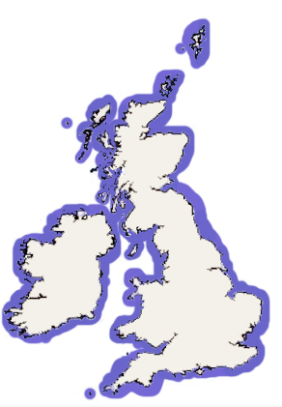
Source: MarLIN 2008
Fig 2 – Average lobster landings by English and Welsh vessels by ICES rectangle, 2006-2012
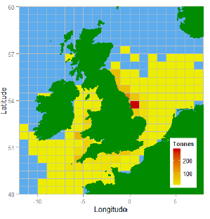
Source: Cefas (2014) Lobster (Homarus gammarus) Stock Status Report 2014.

Description of the fishery

Scope of the fishery in relation to the MSC programme
The fishery under assessment is within scope of the MSC program as defined in FCR v2 Section 7.4.11 (i.e. the target species is not from the following taxa: amphibians, reptiles, birds or mammals; the fishery is not being conducted under a controversial unilateral exemption to an international agreement; nor does the fishery use destructive fishing practices such as poisons or explosives – such fisheries would automatically fail the MSC standard).

Introduced Species / Inseparable Stocks (IPI) / Enhanced Fishery / Low Trophic
These MSC policies do not apply in the case of this fishery and no adjustments to the standard assessment procedure will therefore be required to include these. The fishery does not target non-native or introduced species therefore the MSC Introduced Species Requirements do not apply. The species caught are easily recognizable and can be separated and recorded accurately. And no fishery enhancement techniques (such as artificial reefs) are employed. Finally, the species is not classified as a Key low trophic species.

Overview of the fishery
Although the MSC pre-assessment reporting template includes a number of descriptive sections, because this report is an update of an earlier pre-assessment and because these sections are not normative requirements (i.e. the template indicates that certain sections “may” be included), these have been omitted from this reduced template. Instead, below only very limited description of key fishery parameters are included with the aim of explicitly clarifying the nature of the fishery that is being pre-assessed.
The UK Southwest lobster fisheries comprise coastal inshore pot and trap fisheries prosecuted by smaller (mainly under-10m) vessels targeting lobster, and bycatch from the same or similar vessels targeting edible crab. Catches are also augmented by bycatch deriving from the activities of larger vessels targeting edible crab that split their operations between inshore (generating some lobster bycatch) and offshore (generating limited lobster bycatch) locations. The smaller vessels tend to operate on an exclusively local basis. The larger vessels tend to shift grounds seasonally, as they respond to economic pressures – movements that may take them to other parts of western European waters.
The fishery that is subject to this pre-assessment comprises catches and landings of UK registered vessels operating from the coast of Devon and Cornwall targeting lobster and crab in the Southwest (Western Channel and Celtic Sea – ICES areas VIIe, VIIf, & part of VIIg) (see Fig 3). It largely excludes the operations of vessels registered in Ireland, France and the Channel Islands, and vessels from other parts of England and Wales.
Fishery management jurisdiction is organised on two different scales around England. Beyond 6 nautical miles, Defra and the MMO are responsible for managing lobster fisheries, whereas from the coast out to 6 nautical miles responsibility lies with the Inshore Fisheries and Conservation Authorities (IFCAs). This stock unit and jurisdiction over inshore management within this area rests with three IFCAs – the Devon & Severn, Cornwall, and Isle of Scilly IFCAs (see Fig 4). There are 10 IFCAs within England, and their regions extend from the coast out to 6nm.
Inshore fisheries out to 6nm are, in England, subject to management by Inshore Fisheries and Conservation Authorities (IFCAs). For this fishery, jurisdiction rests with the the Devon and Severn IFCA, the Cornwall IFCA, and the Isles of Scilly IFCA (see Fig 4), though these areas are also subject to, and need to be compliant with, UK legislation. Most targeted lobster fishing takes places within this jurisdiction. Outside 6nm UK registered vessels are subject to management by Defra and the Marine Management Organisation (MMO) of the UK, and subject to EU CFP legislation in its original form or as interpreted in UK law.
Fig 3 – Southwest lobster stock unit area (VIIe, VIIf, VIIg & VIIh)
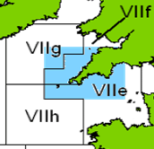
Fig 4 – IFCA areas within Unit of Assessment
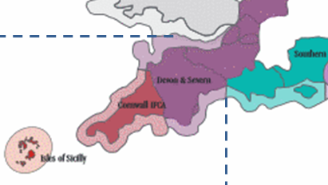

The most productive lobster fishing grounds are to be found in inshore waters on rocky substrate. In most, but not all, cases inshore lobster and crab fishermen deploy the same type of pot in these fisheries but alter the location where the pots are set and the type of bait used to as a means of targeting the capture of one or the other species. The coastal geography of the southwest of England and the Isles of Scilly are particularly well suited as a lobster habitat.
Vessels are fitted out to set and recover fleets of pots, operating typically between 50 and 500 pots per vessel. Larger vessels tend to fish larger numbers of pots, up to as many as 2,000 pots per vessel, but these tend to be used to target edible crab rather than lobster. The technique can be varied to target different species – through choice of pot design, the location of where the pots are set, and the bait used. Accordingly many, though not all, vessels vary fishing activity across the year as they target different fishing opportunities. The main alternate fishing opportunities available are pot fisheries for edible crab, and for whelks, and to a lesser degree seasonal fisheries for cuttlefish and spider crab. These inshore vessels may also periodically engage in handline fisheries – catching for the market and for bait.
Potting and trap fisheries capture marine species other than the target species – so that lobster fisheries have an edible crab bycatch, and conversely edible crab fisheries have a (proportionately lesser) lobster bycatch. All pots and traps are baited, and this actively attracts a number of other bycatch species which can be found in pots on a regular basis, though generally in very small numbers. These include velvet and shore crabs, wrasse and other finfish, and whelks and starfish.
It is unusual for lobster to be caught as a bycatch in fisheries deploying other gear.

Other elements in the fishery
The MSC Fishery Certification Requirements (FCR) v2 which was released on 8 October 2014, and became effective from 15 April 2015 uses different components in scoring Principle 2 to earlier versions of the MSC standard. In the earlier pre-assessment undertaken as part of Project Inshore other species caught in the fishery (referred to as ‘elements’ in the scoring) were defined according to whether a ‘retained’ catch (PI2.1.1-2.1.3) or whether a more unwanted or typically discarded ‘bycatch’ (PI 2.2.1-2.2.3).
The latest version of the MSC standard re-categorises those other species caught in the fishery as either Primary (PI 2.1.1-2.1.3) or Secondary (2.2.1 – 2.2.3), regardless of whether it is retained or discarded. Primary species within Principle 2 are defined as those that have management measures and tools in place intended to achieve stock management objectives reflected in either limit or target reference points (FCRv2 SA3.1.3). If management limits or reference points are not in place then the species is classified as a secondary species (unless it is classified as Endangered, Threatened or Protected).
For Primary species a stock assessment would most likely be available but for secondary species a stock assessment is less likely to be available, therefore, the outcome status of secondary species is likely to be scored using the Risk Based Framework (as per definition in Table 3, Section 7.7.6 of FCRv2).
Table 3 below presents details on whether stock assessments have been undertaken and management and stock status reference points are available; the proportion of catch and whether the species is considered main or minor; and whether the outcome status of the species will be scored using RBF.

Table 3: Summary of how primary and secondary species are assessed within Principle 2
Scientific name | Species | Retained or discarded | % of catch | Main of Minor | Stock assessment | Management limit or ref points | Primary or secondary | Stock status ref points | RBF or default
Cancer pagurus | edible crab | R | >5% | ma | Y | reference points | P_{ma} | y | default
Gadus morhua | cod | R | <½ % | mi | Y | reference points | P_{mi} | Y | default
Dicentrarchus labrax | bass | R | <½ % | mi | Y | reference points | P_{mi} | y | default
Necora puber | velvet crab | R | <½ % | mi | Y | management limit | S_{mi} | y | default
Maia brachydactyla | spider crab | R | <½ % | mi | Y | management limit | S_{mi} | y | RBF
Palinurus elephas | crawfish | R | <½ % | mi | N |  | S_{mi} |  | RBF
Pollachius pollachius | pollock | R | <½ % | mi | N |  | S_{mi} |  | RBF
Buccinum undatum | whelk | D | <1% | ma | Y | management limit | S_{mi} | y | default
Labridae | wrasse | D | <½ % | mi | N |  | S_{mi} |  | RBF
Asterias spp. | starfish | D | <½ % | mi | N |  | S_{mi} |  | RBF
Carcinus maenas | green crab | D | <½ % | mi | N |  | S_{mi} |  | RBF
Conger conger | conger | D | <½ % | mi | N |  | S_{mi} |  | RBF
Raja brackyura | blonde ray | D | <½ % | mi | Y | management limit | S_{mi} |  | RBF
Raja microocellata | small-eyed ray | D | <½ % | mi | Y | management limit | S_{mi} |  | RBF
Raja clavata | thornback ray | D | <½ % | mi | Y | management limit | S_{mi} |  | RBF
Mustelus mustelus | smoothhound | D | <½ % | mi | N |  | S_{mi} |  | RBF

Evaluation Procedure

Assessment methodologies used
The MSC Fisheries Certification Requirements v 2.0 was used to conduct the pre-assessment for this fishery. Although the MSC Pre-Assessment Reporting Template v 2.0 was used as the basis to create this report, some sections which were not normative requirements have been omitted, in particular in relation to the description of the fishery.

Summary of consultations during pre-assessment
This pre-assessment has been undertaken by Crick Carleton during the first half of December 2016. Investigation comprised review of published material, desk research and analysis, and phone contact with representatives of fishery management organisations, fishery scientists and the fishing industry.

Applicability of the default assessment tree
The default assessment tree as provided in FCR v2 has been used to assess and score the fishery. No revisions of the default assessment tree are required.

Approach to Scoring
The MSC pre-assessment process involves a provisional evaluation against MSC Performance Indicators (PIs) and Scoring Guideposts (SGs), to inform how the fishery fares against the MSC standard and whether each PI is likely to fall within the following categories:
Table 5: Key to likely scoring level in Table 6 & Tables A1.1 – A1.3
Definition of scoring ranges for PI outcome estimates | Shading to be used
Information suggests fishery is not likely to meet the SG60 scoring issues. | Fail  (<60)
Information suggests fishery will reach SG60 but may not meet all of the scoring issues at SG80. A condition may therefore be needed. | Pass with Condition  (60-79)
Information suggests fishery is likely to exceed SG80 resulting in an unconditional pass for this PI. Fishery may meet one or more scoring issues at SG100 level. | Pass  (≥80)

Stakeholders to be consulted during a full assessment
The following key stakeholders should be consulted during full assessment:
- National Government – managers, scientists and control and enforcement services
- Local fishery managers (IFCAs)
- Producer Organisations and Fishermen’s Organisations
- Vessel Owners and fishermen
- Supply chain participants / representatives
The stakeholders would be expected to engage in the RBF process for Principle 2 Secondary Species 2.2.1 Outcome Status.

Traceability (issues relevant to Chain of Custody certification)

Eligibility of fishery products to enter further Chains of Custody
It is noted that there is a risk that other lobster landed into the South West of England by vessels that are not in membership of the Unit of Certification could be sold as MSC certified product, or landed to ports landed elsewhere by non-member vessels could carry the MSC logo. The subsequent Chain of Custody assessment would analyse these risks in detail.

Preliminary evaluation of the fishery
The pre-assessment evaluation of the fishery is provided within Table 6. The fishery met level 60 for all Principle 2 and 3 PIs, but failed to reach level 60 for two Principle 1 PIs, and as such the fishery would automatically fail the MSC assessment.
Table 6: Summary of Likely Scoring Levels.
Principle | Component | PI | Performance Indicator | Likely scoring level
1 | Outcome | 1.1.1 | Stock status | ≥80
 |  | 1.1.2 | Stock rebuilding
 | Management | 1.2.1 | Harvest Strategy | <60
 |  | 1.2.2 | Harvest control rules and tools | <60
 |  | 1.2.3 | Information and monitoring | ≥80
 |  | 1.2.4 | Assessment of stock status | ≥80
2 | Primary Species | 2.1.1 | Outcome | ≥80
 |  | 2.1.2 | Management | 60-79
 |  | 2.1.3 | Information | ≥80
 | Secondary species | 2.2.1 | Outcome | ≥80
 |  | 2.2.2 | Management | 60-79
 |  | 2.2.3 | Information | 60-79
 | ETP species | 2.3.1 | Outcome | 60-79
 |  | 2.3.2 | Management | 60-79
 |  | 2.3.3 | Information | 60-79
 | Habitats | 2.4.1 | Outcome | ≥80
 |  | 2.4.2 | Management | ≥80
 |  | 2.4.3 | Information | ≥80
 | Ecosystem | 2.5.1 | Outcome | ≥80
 |  | 2.5.2 | Management | ≥80
 |  | 2.5.3 | Information | ≥80
3 | Governance & policy | 3.1.1 | Legal and customary framework | ≥80
 |  | 3.1.2 | Consultation, roles and responsibilities | ≥80
 |  | 3.1.3 | Long term objectives | ≥80
 | Fishery specific management system | 3.2.1 | Fishery specific objectives | 60-79
 |  | 3.2.2 | Decision making processes | ≥80
 |  | 3.2.3 | Compliance and enforcement | ≥80
 |  | 3.2.4 | Management performance evaluation | ≥80

Key findings from the pre-assessment

Principle 1
Level 60 was not met for the following PIs:
- 1.2.1 – Harvest Strategy
- 1.2.2 – Harvest control rules and tools
These relate to the design, establishment and application of a coherent Harvest Control Rule. Whilst management using Technical Measures does provide some safety net with respect to maintenance of the stock above MSY_{limit} it does not constitute, in the context of the MSC standard, an adaptive management regime, and cannot be demonstrated as being effective in moving stock towards and maintaining it at MSY_{target}. Until these issues are satisfactorily addressed the fishery will fail assessment. The groundwork for pot limits has been established by D&S IFCA opening up the possibility of future establishment of an adaptive management regime.
Level 80 was met for the remaining three PIs within Principle 1.
Lobster is not considered LTL.

Principle 2
The Level 60 was met for all PIs in Principle 2.
There is insufficient clarity with regard to information on the extent of interaction with secondary species, and with ETP species, and this adversely impacts the development and application of strategic to manage and mitigate impacts. In addition, outcomes with regard to ETP populations fall short of SG80 requirements.
Altogether six out of 15 PIs fall short of a score of SG80, and these will draw a significant number of conditions unless redressed prior to entering full assessment.

Principle 3
Level 60 was met for all PIs in Principle 3.
Level 80 was not met for the PI 3.2.1: Fishery specific objectives. A clearer and more coherent of the management objectives for this fishery are required to meet the SG80 level.

Expectations regarding use of the Risk-Based Framework (RBF)
The Risk-Based Framework (RBF) is not required for Principle 1. There is some anecdotal indication that the fishery impacts a number of secondary species, but does so at a very low and occasional level. These species are treated is minor secondary species, where no RBF is required, and attracting a default score of SG80.

Appendix 1 – Pre-assessment Scoring Sheets
Table A1.1: Simplified Scoring sheet – Principle 1
Principle | Component | PI | Performance Indicator | RBF required (y/n) | Likely scoring level | Rationale/ Key points
1 | Outcome | 1.1.1 | Stock status | N | ≥80 | The most recent assessment (2014) indicates that the stock size is above MSY_{limit} but below MSY_{target}, and that the exploitation rate is moderate though increasing in recent years (since 2010). Exploitation is above rates consistent with MSY but below the maximum reference point limit.  At the minimum landing sizes (MLS’s) applied in this region, between 99-100% of the males and 86-92% of the females should be mature. The status of the stock has not changed since the last assessment in 2012.  This will lead to MSC scoring at the SG80 level.
 |  | 1.1.2 | Stock rebuilding | N/A | <60 | As stock is above MSY_{limit} but below MSY_{target}, and exploitation at levels generating MSY, a strategy for stock rebuilding might be expected, but is not in place.
 | Management | 1.2.1 | Harvest Strategy |  | <60 | Stock assessment includes establishment of a minimum biomass reference point limit and MSY_{target}, and fishing reference points of F_{MSY} and a maximum reference point limit. Whilst there is a presumption that management seeks to achieve stocks at MSY_{target}, these are not explicitly reflected in the management of the fisheries within the region.  The following controls seek to achieve a reasonable balance between stock strength and fishing effort and exploitation, but they do not constitute a coherent integrated harvest strategy, and lack any adaptive management component:  - There are limits to the number of shellfish fishing licences issued  - The fishery is subject to minimum size rules (with some area based variation), v-notching schemes, no landing of berried females caught within IFCA areas  - there are some vessel length based restrictions to fishing in IFCA areas.  - There are some specific seasonal limitations within those areas managed by IFCAs, notably in the management of the Start Point Inshore Potting Agreement (managed by MMO with IFCA support) fishery and in and around areas designated for conservation and environmental management.  - There are no limits on the number of pots that can be set (though the foundations for such control have been established within the area of the D&S IFCA).  On balance, whilst a range of technical measures are designed to reduce the risk that stocks might fall below MSY_{limit} they are not designed to and not used to alter fishing activity in response to change in stock status. As such it could be argued that the harvest strategy is not sufficient to support a statement that there is an expectation that the harvest strategy is expected to achieve stock management at or around MSY_{target} and thus might be deemed to score below SG60.
 |  | 1.2.2 | Harvest control rules and tools | N/A | <60 | In large areas of the Devon and Severn IFCA district there is little opportunity to increase the area covered or number of pots on the ground due to the potential for gear conflicts with the mobile fishing fleets. The IFCA and designed and now introduced a pot licenses scheme, which offers the future potential to vary pot numbers used within the IFCA area, but this mechanism has not been triggered as a management tool as yet. No similar schemes exist within the Cornwall or IoS IFCAs.  Fishery Management measures  - national shellfish licence arrangements in place  - national legislation restricts the number of shellfish licences available (in England and Wales) but this also created significant unused latent entitlements  - national & EU lobster MLS of 87mm CL, and national v-notching legislation for lobsters  - using IFCA byelaws  - some have permit schemes  - some establish lobster MLS > the national MLS  - most inshore legislation prohibits landing of berried and soft crabs  - some have vessel size limits  Together, all the above are such as to seek to achieve a reasonable balance between stock strength and fishing effort and exploitation, but they do not constitute a coherent integrated harvest strategy, and lack any adaptive management component.  Based on the assessment units, collaboration between the relevant IFCAs to develop lobster management appears sensible.  On balance, whilst a range of technical measures are designed to reduce the risk that stocks might fall below MSY_{limit} they are not designed to and not used to alter fishing activity in response to change in stock status. As such it could be argued that the harvest strategy is not sufficient to support a statement that there is an expectation that the harvest strategy is expected to achieve stock management at or around MSY_{target} and thus might be deemed to score below SG60.
 |  | 1.2.3 | Information and monitoring | N/A | ≥80 | Fishery management jurisdiction is organised on two different scales around England. From the coast out to 6 nautical miles, responsibility lies with the Inshore Fisheries and Conservation Authorities (IFCAs); beyond 6 nautical miles, Defra and the MMO are responsible for managing.  Most of the lobster fishery is located within the jurisdiction of the IFCAs. This stock unit and jurisdiction over inshore management within this area rests with three IFCAs – the D&S, C, and IoS IFCAs.  Some data on landings, effort, and fleet composition are available (SG60a); fishery removals are monitored and there is some information available to support a CPUE indicator (SG60b); landings from deployment of other gear are very limited – less than 2% of overall lobster landings; there may be other un- / under-reported removals by other gears not accounted for (<SG60c). Given the live nature of the fishery, under-sized lobster, berried lobster and discarded bycatch are returned to the sea live, and assumed to have a high survival rate (>90%).
 |  | 1.2.4 | Assessment of stock status | N/A | ≥80 | The assessment is appropriate for the stock (SG80a) and estimates the status relative to reference points (SG60b). The assessment identifies some sources of uncertainty but does not take them into account (SG60c). Equilibrium assumptions apply. The assessment has not been tested and different approaches have not been explored (<SG100d). The assessment may have been subject to internal, but not external, peer review (<SG100e)
 | Number of PIs less than 60 |  |  |  |  | 2

Table A1.2: Simplified Scoring sheet – Principle 2
Principle | Component | PI | Performance Indicator | RBF required (y/n) | Likely scoring level | Rationale/ Key points
2 | Primary Species | 2.1.1 | Outcome | No | ≥80 | The only main primary species caught in the lobster potting fishery is edible crab. Other primary species, such as occasional catches of cod and bass, are likely to be minor and will not affect scoring below 80, regardless of status.  Edible crab: The most recent (2014) Cefas assessment of the Western English Channel edible crab stock (ICES areas VIIe & h) indicates that it is at MSY_{target} and that the exploitation rate is around the level generating MSY (females above, males below). The status of the stock has not changed since the previous assessment in 2012.  Exploitation rates show slight continuing decline in recent years, whilst there is some evidence that the introduction of the Restrictive Shellfish License Scheme and Buyers and Sellers legislation has resulted in fishing activity data being generally more reliable.  2013 data suggests exploitation within this stock unit by a fleet of 221 under 10m vessels, and 38 over 10m vessels, apply an average of 41 and 96 vessel days fishing (noting that a proportion of the under 10m fleet is inactive or fished on a part-time basis) (>SG80).  The status of the stock of female Edible Crab in the Celtic Sea is approaching the level associated with Maximum Sustainable Yield. Exploitation levels are moderate for females and likely to be sustainable but above the target MSY level. The status of the stock has not changed since the last assessment in 2012.  Edible crab is expected to be above the point where recruitment would be impaired (the PRI).
 |  | 2.1.2 | Management | N/A | 60-79 | Management of the Western Channel and Celtic Sea edible crab stocks units is according to reference points and informed by stock assessment, in turn informed by appropriate levels of data collection.  Shark finning is not taking place.  The final scoring issues (e) is new to the latest version of the MSC standard MSC CRv2) and requires that there is a review of alternative measures to reduce unwanted catches of unwanted main primary species. Since edible crab is a secondary commercially valuable target species in this fishery, this does not apply in this case.  In the context of other, for example finfish, primary species the level of bycatch is occasional only, and well below 2% of total catches. Review of measures to further reduce such catches is relevant, but is likely to have minimal impact of the status of these species. Of note, most lobster pots and many crab pots are fitted with escape hatches to allow undersized crustaceans and some finfish to escape.  There is a strategy in place for management of edible crab fisheries, and there are measures in place where considered necessary (SG60a+; SG60b+).
 |  | 2.1.3 | Information | N/A | ≥80 | Qualitative and some quantitative information is available through the RBS & shellfish return data collection (SG80a). This is sufficient to support a strategy for management of the edible crab catches as a main primary species (SG80c) and indicate any increased risk from this fishery to this species (SG80d). Data capture with respect to capture of other minor primary species is poor, reflecting the very low and occasional levels of capture of these species.
 | Secondary species | 2.2.1 | Outcome | Yes | ≥80 | Project Inshore identified three non-target species – velvet crab, spider crab and edible crab. Of these only one, edible crab, may be treated at a main (addressed above as a primary species), with the remainder addressed a secondary minor.  Of note, edible crab, velvet and spider crab fisheries are recognised as targeted fisheries (fished using different or modified gear, different bait, and with pots set in different areas and/or on different substrate) in which lobster may be viewed as a bycatch species.  In addition to the above, however, anecdotal and some survey evidence suggests that minor catches of a range of other species are also made.  Since these pot fisheries are a live fishery, all non-retained bycatch is returned to the sea live – with a recognised high survival rate (>90%).  No main secondary species have been identified for this fishery, but a range of very low volume (<½%) bycatch species can be identified as minor secondary species. These secondary minor species are – whelk; velvet crab; spider crab; crawfish; pollock; wrasse; starfish; green crab; conger; blonde ray; small-eyed ray, thornback ray and smoothhound. Only one of these, whelk (also the subject of a high volume targeted fishery that uses quite different gear), may involve a slightly higher volume (at <1%) (see Table 3 in the main text).  Given their classification as minor secondary species, they are scored at or above SG80.
 |  | 2.2.2 | Management | N/A | 60-79 | Whelk, velvet and spider crab fisheries and harvests are subject to periodic monitoring, but not actively managed beyond establishment of minimum sizes.  Crawfish and pollock stocks are considered as data-poor and vulnerable to exploitation.  Starfish, green crab and conger populations are not considered at risk, and when caught as bycatch specimens are normally returned to the sea live.  Ray populations are considered data-poor and vulnerable to over-exploitation. Caught as bycatch to this fishery, specimens are very small and returned to the sea alive. Thornback ray and smoothhound are classified by IUCN as endangered and vulnerable respectively.  None of the above is assessed as warranting a score below SG80.
 |  | 2.2.3 | Information | N/A | 60-79 | Catches of commercially valuable and above minimum size specimens of crustaceans are typically recorded in shellfish returns, but for the rest data availability is poor.  Periodic independent assessment of catches is made as part of IFCA monitoring and research programmes, but this does not form part of a coherent and coordinated monitoring of bycatch.
 | ETP species | 2.3.1 | Outcome | No | 60-79 | No ETP species associated with this fishery were identified in the Project Inshore pre-assessment – and this is supported by available survey data. It is also the case that all catches that are not retained are returned live to the sea.  Nonetheless, data capture with respect to incidental catches and catches of organisms of little to no commercial value is poor to non-existent and hence a proposed scoring at <SG80.
 |  | 2.3.2 | Management | N/A | 60-79 | Although the Management Strategy PIs across Principle 2 typically require a ‘Partial strategy’ at the SG80 level. For the ETP management PI (2.3.2) there is a requirement at the SG80 level for a ‘strategy’. In other words, the management threshold is higher for ETP than for other Principle 2 components.  Whilst anecdotal evidence suggests that interaction with ETP species are minimal, it is not clear at present what the level of potting interaction with these species is, and no management strategy to manage such impact is in place.
 |  | 2.3.3 | Information | N/A | 60-79 | Catches of commercially valuable and above minimum size specimens of crustaceans are typically recorded in shellfish returns, but for the rest data availability is poor.  Periodic independent assessment of catches is made as part of IFCA monitoring and research programmes, but this does not form part of a coherent and coordinated monitoring of bycatch.  Despite this, this fishery is likely to have but limited impact on populations of any ETP species.  No specific recording of ETP species by fishermen is required or encouraged, though this is included where independent surveys are undertaken.
 | Habitats | 2.4.1 | Outcome | No | ≥80 | The static gear used to prosecute the fishery is in contact with the bottom, but unlikely to have significant interaction with vulnerable habitats. The habitat risk of this fishery has been identified as low risk. Evidence suggests fishery impact on the bottom is restricted to some abrasion caused by dragging pots and anchors during hauling and tide and wave action (Grieve et al., 2014).  There are a significant number of areas given environmental protection designation within this fishery, comprising mainly SACs, SPAs, and MCZs. In most cases active management of these areas limits or excludes fishing with mobile gear, but allows fishing with static gear and impact of such fishing is monitored.  Discrete areas on the deep water periphery of the area under assessment are designated as Vulnerable Marine Ecosystems (VMEs), where potting is excluded. These vulnerable marine habitats are protected within the Convention for the Protection of the Marine Environment of the North-East Atlantic (OSPAR, 2013) and any kind of fishery there might be controlled if deemed necessary.
 |  | 2.4.2 | Management | N/A | ≥80 | There is a comprehensive strategy in place through the combination of International, EU, UK and local management regimes – both across the area, and where designated areas are subject to specific management conditions.  This strategy is likely to work, and there is previous evidence of measures being implemented in order to protect at-risk habitats (e.g. ban on benthic gear in certain areas).  Quantitative evidence exists to show the strategy is being implemented successfully.  No direct evidence of VME compliance has been seen, though the presence of on-board VMS systems mean evidence is likely to exist.
 |  | 2.4.3 | Information | N/A | ≥80 | Active monitoring of areas subject to specific environmental designation does take place, and irregular sampling and monitoring of habitat outside these areas is also conducted, though primarily inside the 6nm limit. Ongoing monitoring for habitat risks forms part of the strategy.  Despite the foregoing, a greater level of information on the impacts of the UoA is necessary to assess the impacts of the UoC.
 | Ecosystem | 2.5.1 | Outcome | No | ≥80 | There is a presumption that static potting gear impact on the ecosystem is low risk and this has been borne out by studies to date. Some specific assessment of parts of the Start Point managed area (subject to the Start Point Inshore Potting Agreement) has been undertaken, and this has shown overall improvements in biodiversity where mobile gear has been seasonally or totally banned in an area, and where potting continues to be conducted.
 |  | 2.5.2 | Management | N/A | ≥80 | There is an increasing focus on ecosystem management at the EU CFP and ICES advisory level (WGCRAB), and where designated areas are subject to specific environmental management (SPAs, SACs, MCZs and VMEs). Recent evidence for this includes the issuing by ICES of mixed fisheries advice and proposals for mixed fisheries multi-annual management plans.  In addition, there is considerable focus at an EU level on the marine Ecosystem. For example, the EU Marine Strategy Framework Directive requires member states to assess the current state of their seas against agreed targets for ‘good environmental status’ and to establish both a programme of measures to meet these targets and a monitoring programme to measure progress.
 |  | 2.5.3 | Information | N/A | ≥80 | The work of the IFCAs and their predecessor Sea Fisheries Committees has ensured improved knowledge and awareness of the state of the marine environment within the 6nm inshore regime.  This has been substantially enhanced with the national policy to identify and establish Marine Conservation Zones (MCZs), to support the assessment by Cefas of shellfish stocks in inshore English waters, and the need to design and implement a revised approach to fisheries management in European Marine Sites (EMS).  Outside the inshore zone, projects such as CHARM (eastern Channel) and MESH (western Channel) have ensured a broad brush scoping of the environmental characteristics of the other offshore areas that fall within the scope of this assessment, and increased integration of the work of environmental and fishery management institutions (through Natural England and the MMO) has resulted in greatly enhanced knowledge and understanding of the marine ecosystem. This information has been used in part to inform improved marine spatial planning.
 | Number of PIs less than 60: |  |  |  |  | 0

Table A1.3: Simplified Scoring sheet – Principle 3
Principle | Component | PI | Performance Indicator | RBF required (y/n) | Likely scoring level | Rationale/ Key points
3 | Governance & policy | 3.1.1 | Legal and customary framework | N/A | ≥80 | The Southwest lobster fisheries take place exclusively within waters governed by the European Union, within the UK EEZ, and within the Territorial Seas of England.  There is therefore a need in the MSC requirements of both an "effective national legal system" and also "organised and effective cooperation with other parties" (scoring issue a). Effective and organised cooperation within the EU occurs through the Common Fisheries Policy (Regulation (EU) No 1380/2013 of the European Parliament and of the Council of 11 December 2013 on the Common Fisheries Policy).  Management is informed by data collection and stock assessments on the basis of stock units – which for this assessment is the Southwest England stock unit, as organised by Cefas.  On a wider scale scientists from EU member states collaborate effectively in the provision of stock and biological information through ICES, which provides oversight in respect of management of lobster stocks and exploitation through WGCRAB.  Effective national legal systems exist throughout European Member States implementing the CFP. At a European and national level a clear legal process is evident to resolve disputes and observes the legal rights of all UK citizens, including people dependent on fishing. At both a national and EU level there is an effective mechanism for the resolution of legal disputes (scoring issue b).  Within the UK there is an effective national legal system implementing both the CFP and domestic fisheries law. More local interests are represented in inshore management regimes applying in sea areas out to 6nm from baseline. Along the English coast within areas VIIe and VIIf these are under the management of the D&C IFCA, the Cornwall IFCA and the IoS IFCA.  No "rights created explicitly or established by custom of people dependent on fishing for food or livelihood" have been identified (scoring issue c). As a result scoring of this PI is likely to be at the SG80 level or above.  The decision of the UK electorate on June 23, 2016 to leave the European Union (i.e. 'Brexit') looks likely to begin a process in which the UK will repeal key EU legislation – perhaps including the CFP, subsidiary laws and marine environmental legislation – although with the potential to absorb parts of EU legislation directly into UK legislation. Scoring in this pre-assessment is based upon the situation at the time of writing and makes no predictions about how the process will proceed. However, at the time of any full assessment it will be important to demonstrate that there is still "organised and effective cooperation with other parties" to deliver management outcomes consistent with MSC Principles 1 & 2.
 |  | 3.1.2 | Consultation, roles and responsibilities | N/A | ≥80 | These lobster fisheries are managed at national and local levels, albeit within a context of collaboration between Member States. The management unit for stock purposes is the Cefas Southwest lobster stock unit, with management from a UK perspective vested in the IFCAs inside 6nm and the MMO outside 6nm.  The division of responsibility for management of non-quota shellfish, such as lobster, is poorly defined – both management and science. The Marine and Coastal Access Act 2009 gives joint responsibility between MMO and IFCAs. MoUs seek to clarify, but are still not explicit, instead talks in terms of general principles of collaboration & joint working. The MoU recognises that further guidance is necessary. In practice, most of the lobster fishery takes place within 6nm of the shore, and thus within the jurisdiction of the IFCAs.  Consultation: lack of representation in inshore fisheries has been a historic problem, which makes effective consultation harder. IFCAs are not a statutory consultee in marine planning applications – instead this is the MMO, central office.  Overall enforcement of regulations lies with the MMO, and is devolved to the IFCAs inside 6nm.  The process of fisheries representation is well established and representative bodies (such as NFFO in England) are formally involved in the consultative processes of management through Regional Advisory Councils (i.e. the Western Waters Advisory Council) and it and local fishermen’s organisations are represented through the IFCAs. There are examples of extensive consultation processes, such as on the latest reform of the CFP, and the UK establishment of MCZs.
 |  | 3.1.3 | Long term objectives | N/A | ≥80 | Clear long term objectives consistent with MSC principles and criteria are explicit in the management system at EU and UK levels. The minister would only sign off on either a Regulating Order or a byelaw if it is shown to be consistent with national / EU strategies.  This PI seeks to ensure that “Management Policy has clear long-term objectives to guide decision-making that are consistent with MSC fisheries standard and incorporate the precautionary approach”. This PI assesses objectives contained in high level or broader government policy, rather than on fishery specific operational objectives. The overarching objectives which are binding on all subsidiary pieces of fisheries legislation are those defined in the EU Common Fisheries Policy Legislation. Article 2 of the CFP legislation sets out these objectives. These are explicit and in line with the MSC Principles & Criteria.  There is also explicit mention of the Precautionary Approach and the Ecosystem based approach to fisheries management. At the UK level, the Marine & Coastal Access Act 2009 which establishes the MMO, states that the organisation must operate in accordance with the Government’s principles of sustainable development. In 2009 the UK Government (including the devolved administrations) published a set of High Level Marine Objectives within “Our Seas: A Shared Resource” which further details these high level objectives. These high level objectives at both an EU and UK wide level which guide management decision making are fully consistent with the MSC fisheries standard and would support scoring at the SG80 level.
 | Fishery specific management system | 3.2.1 | Fishery specific objectives | N/A | 60-79 | The IFCA byelaw review process, or any new process of byelaw application, must go through the processes set out in the DEFRA guidance for IFCAs on evidence based marine management.  Based on the assessment unit, collaboration between the relevant IFCAs to develop lobster management appears sensible – which have jurisdiction over the main proportion of activity and exploitation.
 |  | 3.2.2 | Decision making processes | N/A | ≥80 | Management of fishing activity is primarily conducted locally, albeit within an overall UK and EU framework.  Decision-making is achieved at a national level through the MMO, with significant professional inputs from the research laboratories (Cefas with respect to England and Wales), the Shellfish Committee of the Shellfish Association of Great Britain (SAGB), the Shellfish Committee of the Seafish Industry Authority, the IFCAs (England and Wales) and Inshore Fisheries Groups (Scotland), and Fishermen’s Organisations and Producer Organisations.
 |  | 3.2.3 | Compliance and enforcement | N/A | ≥80 | Compliance is good but variable. Monitoring and surveillance systems are well established and functioning well – to the limits of their design and available resources (given that there are no formal limits to the number of pots that can be fished by a vessel, and minimal controls on the minimum or maximum days a vessel can operate in a year.)  Key controls comprise variable access rules between IFCAs (including a permit scheme run by Cornwall IFCA) and applying to specific management areas (Start Point Inshore Potting Agreement; designated conservation areas), and technical measures (primarily minimum landing sizes – noting that there are some differences between IFCAs). The D&S IFCA has also recently introduced a pot licensing scheme.  Enforcement is exercised through the submission of landings data under the Buyers and Sellers Regulation, at sea observation and occasional at sea inspections (by IFCAs, and by the Sea Fisheries Inspectorate and the Royal Navy), and market / trader inspections. Larger vessels – over-15m by law, moving to over-12m by law – are required to carry satellite mediated vessel monitoring systems. Smaller vessels are being encouraged to carry inshore (VHF and/or GPRS mediated) VMS (a key element within the D&C IFCA pot licensing scheme). Ongoing science programmes also allow a degree of ground-truthing and elaboration of activity and landings data.
 |  | 3.2.4 | Management performance evaluation | N/A | ≥80 | The ICES Working Group WGCRAB considers information and comments on management, but this could not be considered a fishery-specific management review.  The UK lobster fishery is subject to a very course form of overall management (and objective), but each region tends to seek to achieve management in its own way – and so a clear management strategy and objective is not established.  Management of the Southwest lobster stock / fishery can be viewed as a mosaic of different regimes – disaggregated on the basis of whether conducted inside or outside the 6nm inshore limit, and whether or not subject to further restrictions associated with a particular area management designation (whether for environmental reasons, or to achieve some degree of gear separation).  The Cefas Southwest stock assessment is used to inform local management decisions – which are made separately by each IFCA within a framework formulated by the MMO. These controls are reviewed locally, but not on a coherent basis. These management decisions are, however, subject to periodic review by the SAGB Shellfish Committee.
 | Number of PIs less than 60: |  |  |  |  | 0

Appendix 2 – References

- Acrunet (2015) Atlantic Crab Resource Users Network - http://www.acrunet.eu/
- Bannister R C A (2009) On the Management of Brown Crab Fisheries; Shellfish Association of Great Britain
- Bannister R C A (2014) Running the marathon: an SAGB perspective on attempts to improve the management of our pot fisheries; presentation to the NFFO Shellfish Summit, October 2014 - http://nffo.org.uk/responsible-fishing/nffo-shellfish-summit-report/
- Cefas (2015) Cefas Stock Status Report 2014 – lobster
- Clark S (2008) South Devon Potting Effort Survey 2008
- Clark S (2014) IFCA Shellfish Management: presentation to the NFFO Shellfish Summit, October 2014 - http://nffo.org.uk/responsible-fishing/nffo-shellfish-summit-report/
- Dapling T.M., Clark R.W.E., & Vause B.J., Medley, P., C.R.C. Carleton (2010). "Navigating the Future‟. Developing Sustainable Inshore Fisheries. The UK Inshore Fisheries Sustainability Project"
- Derriman E (2014) The UK Lobster Fishery from an Economic, Cultural and Social Perspective; presentation to the NFFO Shellfish Summit
- Finding Sanctuary (2011) Final Report and Recommendations + 7 appendices – http://publications.naturalengland.org.uk/publication/1561560
- Grieve C, D. Brady & H Polet (2014) Best practices for managing, measuring and mitigating the benthic impacts of fishing; MSC Science Series
- Hold, N., Murray, L. G., Pantin, J. R., Haig, J. A., Hinz, H., and Kaiser, M. J. (2015) Video capture of crustacean fisheries data as an alternative to on-board observers. – ICES Journal of Marine Science, doi: 10.1093 / icesjms / fsv030.
- ICES (2015) Interim Report of the Working Group on the Biology and Life History of Crabs (WGCRAB), 3–5 November 2015, Brest, France. ICES CM 2015/SSGEPD:11. 43 pp.
- Kaiser M, H Hinz, R Callaway A Nall & C Biles (2005) Resource degradation: a subtle effect of bottom fishing
- Kaiser M (2014) The Conflict between Static Gear and Mobile Gear in Inshore Fisheries: Report prepared for the European Parliament: Policy Department B: Structural and Cohesion Policies - Fisheries
- McLennan S & Y Apostolaki (2014) A snapshot of Shellfish Policy…; a Defra industry presentation
- Nash B & C Eatock (2013) Landings per unit effort for Edible crab, Cancer pagurus, within the Cornwall Inshore Fisheries and Conservation Authority District for 2011; Falmouth Marine School
- Nautilus Consultants (2009) Future Management of Brown Crab in UK and Ireland; report to The UK & ROI Brown Crab Working Group NFFO (2010) Effort Limitation in the Shellfish Fisheries: NFFO Policy Brief
- Pantin, J.R., Murray, L. G., Hinz, H., Le Vay, L. and Kaiser, M. J. (2015a). The Inshore Fisheries of Wales: a study based on fishers’ ecological knowledge. Fisheries & Conservation report No. 42, Bangor University. Pp.60
- Pantin, J.R., Murray, L.G., Cambiè, G., Le Vay, L. & Kaiser, M.J. (2015b). Escape Gap Study in Cardigan Bay: consequences of using lobster escape gaps. A Preliminary Report. Fisheries & Conservation report No. 44, Bangor University. 43 pp.
- Rees A (2015) The Lyme Bay Experimental potting project - A short summary of Cancer pagurus; Report to Devon and Severn IFCA
- Robert Blyth, R., Kaiser M, Hart P, & Edwards-Jones G (2003) presentation on The Inshore Potting Agreement: A Model For Inshore Management - http://www.shellfish.org.uk/files/Conferences/Pre-2010/the_inshore_potting_agreement_a_model_for_inshore_management_sagb_conference_2003.pdf
- Seafish (2014) Ecological Risk Assessment of the effects of fishing for South West fisheries; ICES Divisions VII e,f,g & h; Seafish Report SR 670
- Seafish (2016) Risk Assessment for Sourcing Seafood (RASS): Lobster on the Southwest Coast, England, Pots
- Southall T. D, Cappell R, Hambrey J.B, Hervas A, Huntington T.C , Medley P.A.H, Nimmo F, Pfeiffer N & Tully O. (2013). Project Inshore Stage 2 Report. Prepared for Seafish by Food Certification International Ltd. Available for download (link verified October 2016)
http://www.seafish.org/media/921067/2013.07.23_project_inshore_s2_v5.pdf
- Tully O (editor) (2004) The Biology and Management of Clawed Lobster (Homarus gammarus L.) in Europe; Fisheries Resource Series, Bord Iascaigh Mhara (Irish Sea Fisheries Board), Dun Laoghaire, Ireland
- Tully O, M Bell, A O’Leary, A McCarthy, V O’Donovan, & D Nee (2006) The Lobster (Homarus gammarus L.) Fishery: Analysis of the Resource in 2004/2005. Fisheries Resource Series, Bord Iascaigh Mhara (Irish Sea Fisheries Board), Dun Laoghaire, Ireland, Vol. 6, 2006, 58pp
- Walmsley S, A Bowles, C Eno, & N West (2015) Evidence for Management of Potting Impacts on Designated Features – MMO Contract Reference 1086

Appendix 3 – Graphics
Lobster catches, by ICES square – from MMO landings statistics, 2014
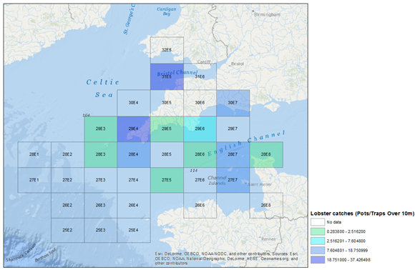
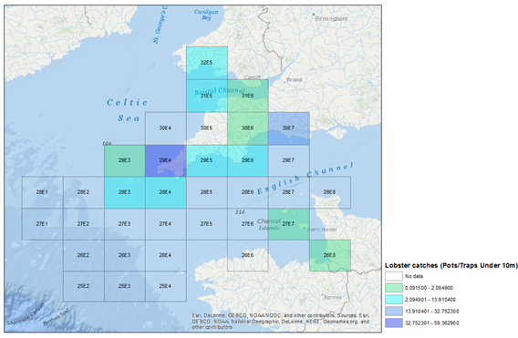

EMODnet screen grab showing seabed substrate – http://www.emodnet-seabedhabitats.eu
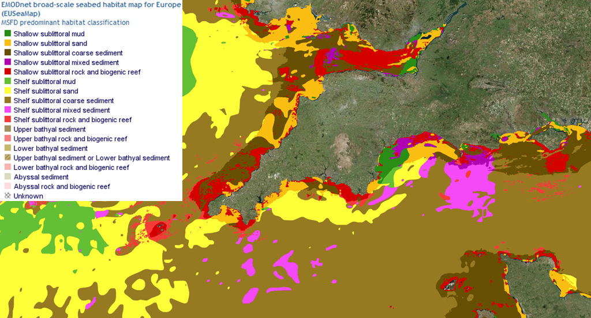

Designated Marine Protected Areas - http://jncc.defra.gov.uk/page-5201
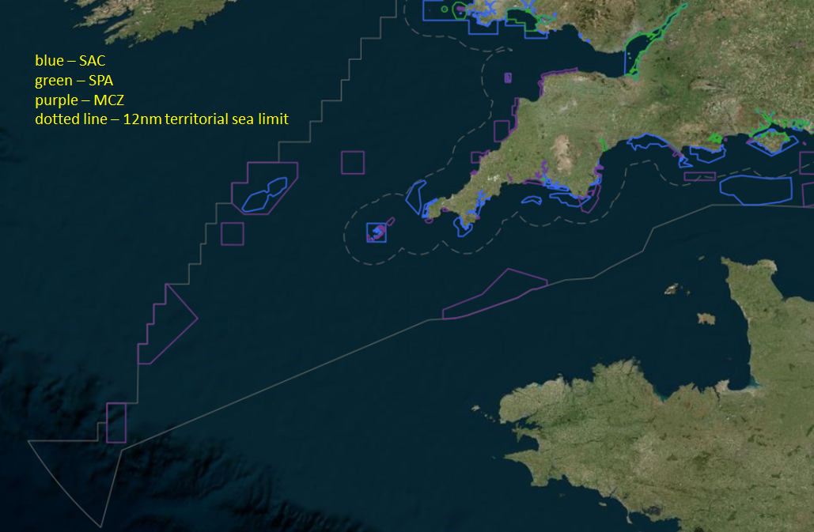

Futher details about Project Inshore, along with all reporting outputs are available on the Seafish website: http://www.seafish.org/industry-support/fishing/project-inshore
MSC CRv2.1 Version 2.1 | Issued: 20 February 2015 | Effective: 1 September 2015. Available for download at: https://www.msc.org/documents/scheme-documents/fisheries-certification-scheme-documents/fisheries-certification-scheme-documents#FCR
With the exception of Sussex IFCA, which already had relevant results from an earlier project (Dapling et al 2010) which piloted the multi species MSC pre-assessment approach.
http://www.seafish.org/industry-support/fishing/project-inshore/project-reports/stage-two-reports
http://msc.solidproject.co.uk/msc-project-inshore.aspx
Assumed to be those vessels that sign-up to the client group management unit, and meet and comply with its rules – assumed to primarily comprise those vessels located and operating from South West ports, as well as those vessels in membership of regional POs.
The Welsh inshore fisheries are managed directly by the Welsh Assembly Government with, in contrast to the IFCAs in England, jurisdiction extending to 12 nm.
“smelly” bait (such as salted mackerel or herring) is used when lobster is targeted; fresh bait (such fish frames and parts of fish) is used where edible crab is targeted

